Digital CQ – User Guidance

Login Page
Use Login to access the system. If you do not yet have an account, request one from an admin:
- Joanne Milner
- Damian World
- Lewis Simcoates
An admin will provide a temporary password. Log in using your FTS email address and the temporary password, then change your password. Details regarding password change will be provided below.
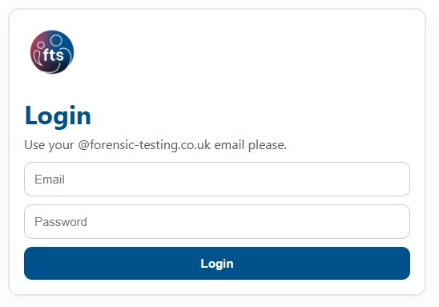

Dashboard Page
The dashboard has three main sections:
Create Questionnaire – Enter the case number and select New Draft.
Search – Search using the FE or case number.
Recent Questionnaires – View, open drafts, open submitted (read-only), generate PDFs (for uploading to empirical), copy questionnaires, or delete (admins only). Any case that is copied will have its signatures automatically removed.
Pressing Generate PDF will automatically download the completed client questionnaire, which has new branding and styling.
The delete button will not be available to non-admins.
Top Navigation
Change Password – Update your password.
Admin Tools – Admin-only feature, which includes user control and data download. More on this later in the document. This button will not be available if you are not admin.
Refresh – Reload cases.
Sync – this is a feature to be used if/when you are reconnecting from offline mode and cases made offline do not appear automatically. More explained later.
Logout – Log out.
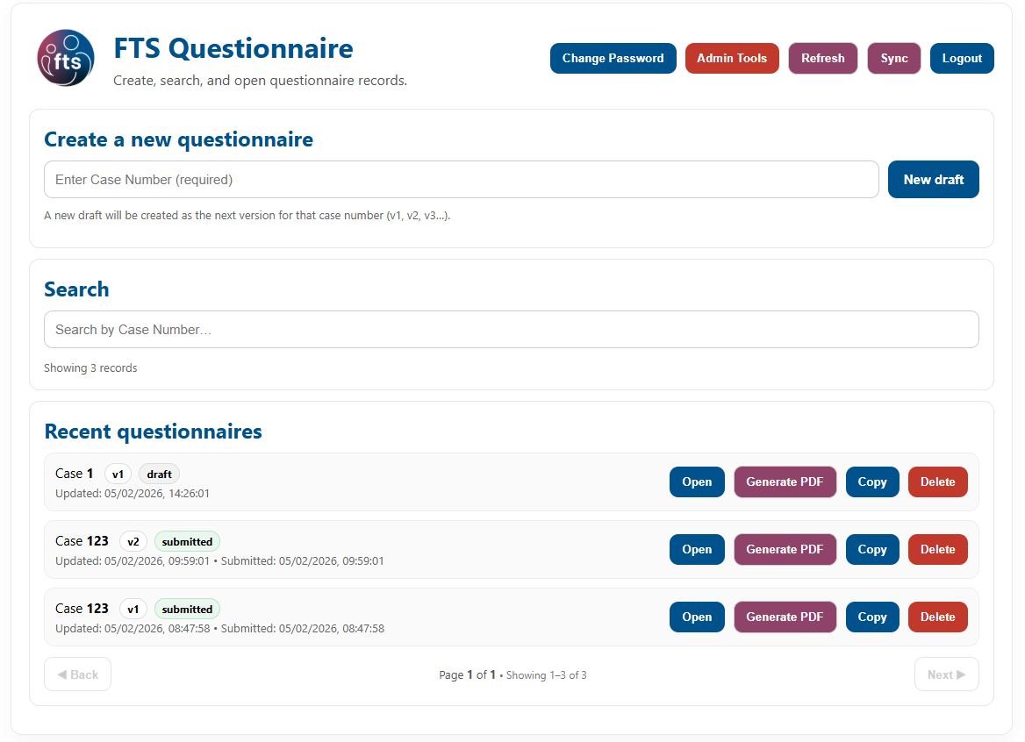

Questionnaire Page
Forms are split into sections for ease of use and data recording. Most sections on the form need an input before submission.
If any required fields are not complete it will not let you submit a form. However, required fields are highlighted if they are missing (at submission). Drafts can be saved without being complete.
Please try to input something in every section/answer every question.
Personal Details & Consent
These are standard questions about the client, and information needed about whether we gain consent or not.
Pressing “No” on the consent will bring up the refusal section, which needs completing and signing. No further questions will be displayed.
“Yes” on the consent opens the rest of the form dynamically.
Drug Use Table
Next is the drug table, for ease of use all drugs we test on the standard drug panel are included in this table. Fill out the table as appropriate for each drug, each row needs used or not used for each drug.
On each row there is a use or non-use check box for each drug – one of these selecting.
Next there is start date and end date for periods of use- and an unsure option if these are unknown. There can be multiple periods of use input for each drug row - if the any fluctuations the end checkbox can be selected and a new child row will appear which can be filled out in the same way for a different period. So the best way to approach is in chronological order and split the declaration up as appropriate. A level of use needs selecting as well – unsure is an option.
All drugs that can be prescribed have a prescribed check option, which needs clicking if appropriate.
Each row needs completing. The start date picker has some helper shortcuts for the dates (-3 and -6 months).
At the bottom of the table, there is an additional info free text field which can be utilized.
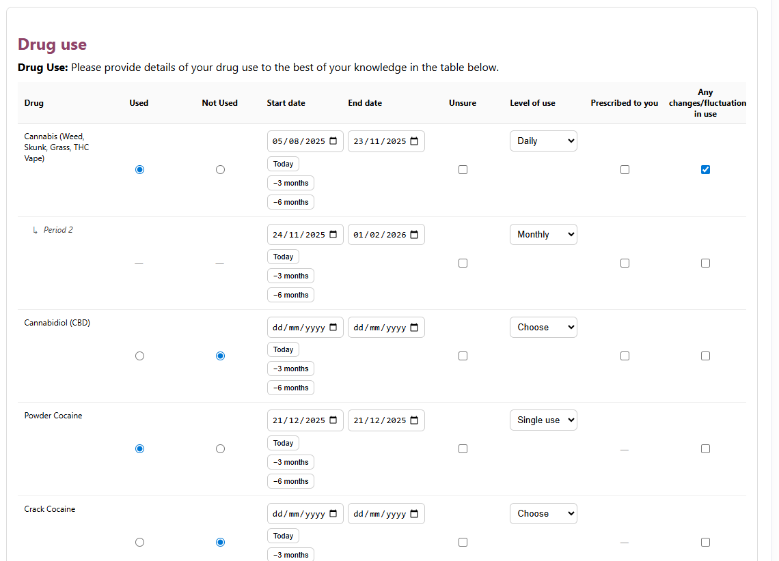
Example completion – please note the cannabis declaration which highlights how to document fluctuations. This reads as daily cannabis 5th August to 23rd November 2025 and a reduction to monthly since then, from around 24th Nov to 1st Feb.
Cocaine has also been used on a single occasion, with no other fluctuations.
Exposure Table
There is an overarching yes/no exposure question which dynamically controls the exposure table. But if yes is clicked a similar table to the drug use one appears.
Similarly to the drug use table, each row needs completing with each column having an entry if applicable. Again there is a free text field at the bottom and fluctuations can be recorded on child rows.

Medication
All the drugs we test for are already included in the drug and exposure tables. So this yes or no is for any other drugs not currently mentioned. When “yes” is clicked a free text field opens for an input.
Alcohol Consumption
Compared to the previous questionnaire this section has been streamlined massively. Now there are just 3 main questions:
Any alcohol consumption? Yes/No
Last use – please provide a data or click unsure.
Then average frequency – this will need calculating and an average provided. This is similar to how it is asked for in the NHS. A helper diagram appears when Yes is clicked to help calculate the average.
For example, some one says “2 bottles of wine every other week”. This corresponds to approximately 20 units every 2 weeks, which is 10 units a week – so would be low.
With this new system less detail over changes in alcohol consumption can be recorded but we get the critical information: average consumption and recent abstinence – if applicable (which is from the date last used).
Any further information can be recorded in the text field.

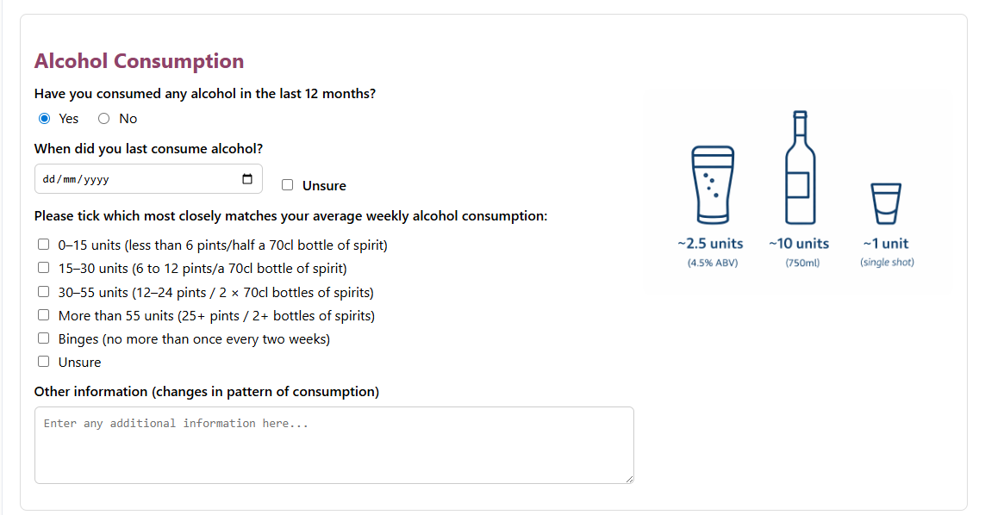
Hair Cutting & Influencing Factors
Many of the questions in this section are dynamic and more or less appear based on other responses. Please complete all questions. This outlines all the information needed by prep, lab and tech.
Signature section
E-sign is built into the document – name, date and signatures are needed.
At the end you can save draft if the document is not complete yet or submit if it is all completed and signed.
The home button in the top left and bottom right take you back to the dashboard if needed.
Admin Tools- These are available to admin users only.
Export submitted questionnaire – apply all necessary filters and download data in JSON or CSV format.
Create user – here you input an @forensic-testing.co.uk email and make a new user and select their role. It will present you with a temp password to share with said user.
Users – this is the user management system. Where permissions can be upgraded and users deleted if needed.
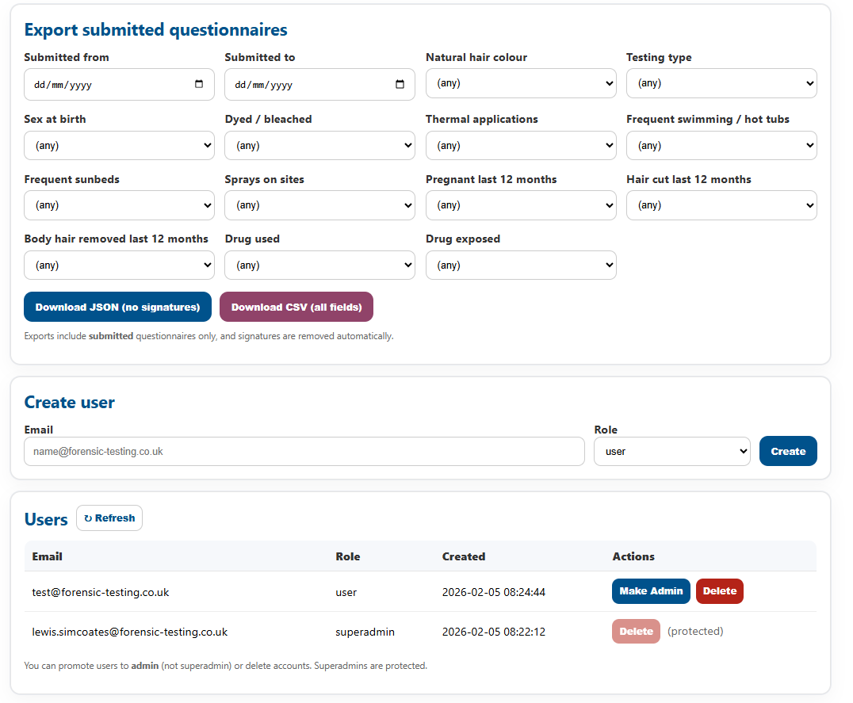

Offline Mode
For offline mode to work, the device being used needs to have previously been logged into the application online. You can login while offline if this is the case.
When in use there will be an offline banner which spans the top of the app on every page.
New CQ’s can be created and saved offline, all in the same way.
However, they will be stored locally until connection is restored. On reconnection they should automatically sync to the database and upload, but if not then you need to select the sync option on the dashboard.
PDF generation will not work offline but can be done once connection is restored.

